Configuring a Static Website with S3 and CloudFront

Create an S3 Bucket
- Go to AWS Console
- Search for S3
- Click Create bucket

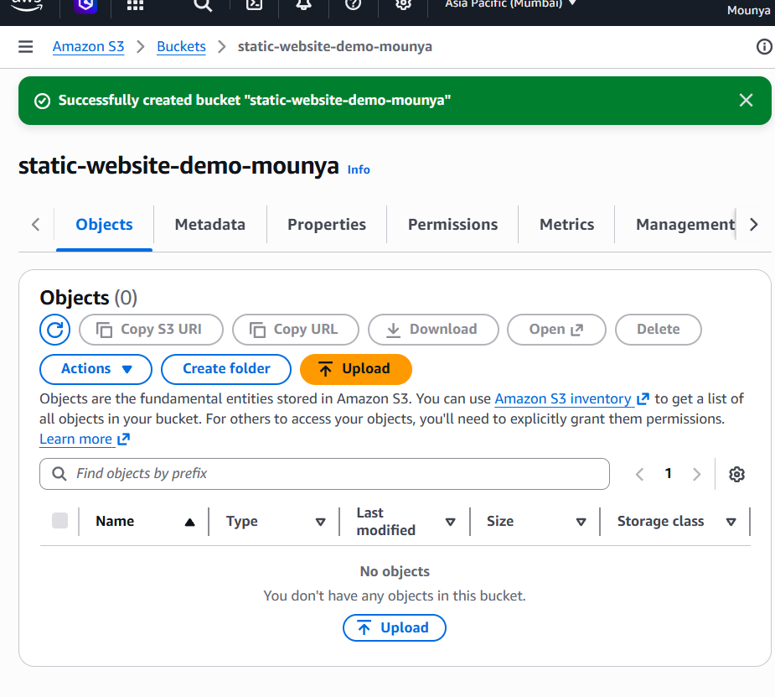
Enable Static Website Hosting
- Open the bucket
- Go to Properties tab
- Scroll to Static website hosting
- Click Edit
Select:
✅ Enable ✅ Host a static website

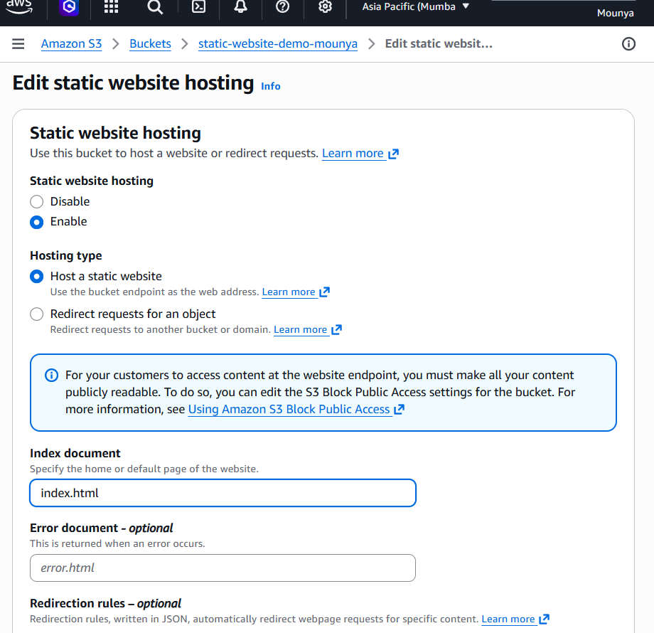

Now, Create a simple index.html file on your computer
Upload it:
- Go to Objects
- Click Upload
- Select index.html
- Click Upload
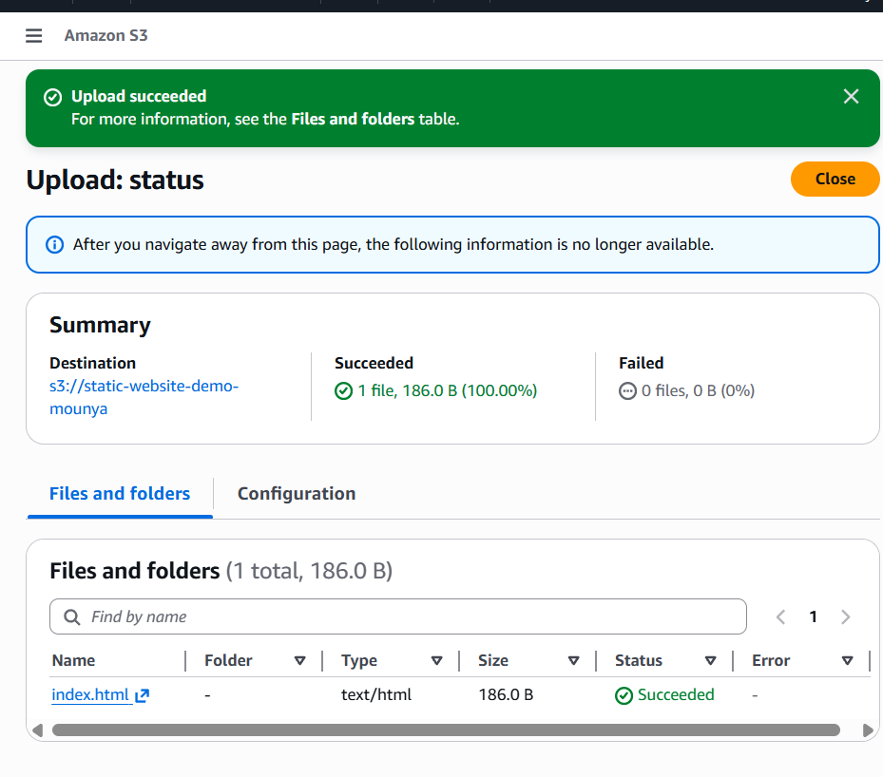
Make the Bucket Public (IMPORTANT)
A. Disable Block Public Access
- Go to Permissions tab
- Scroll to Block public access
- Click Edit
- ❌ Uncheck all options
- ✅ Confirm
- Click Save changes
- Still under Permissions → Bucket policy, click Edit

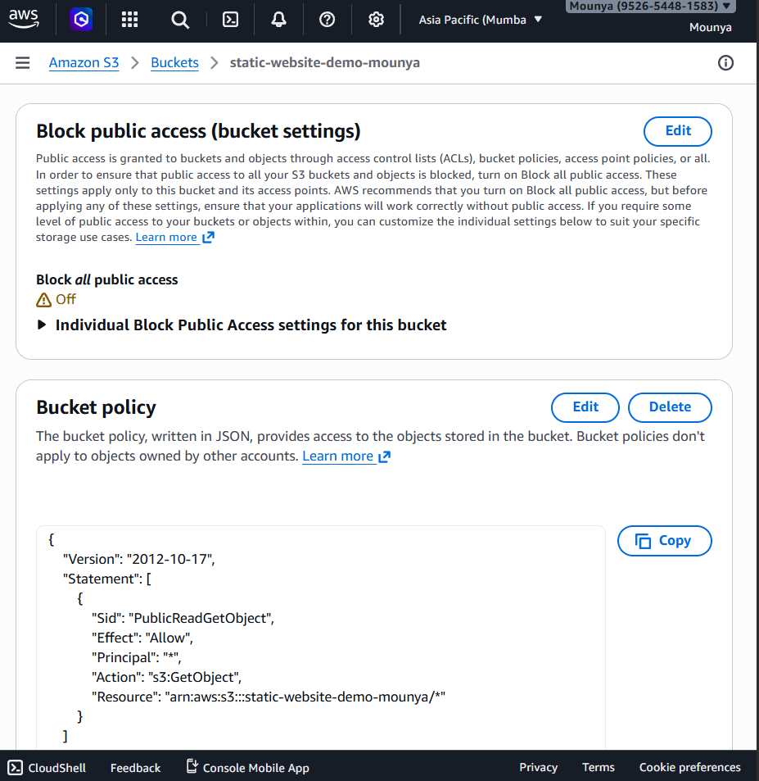
Access the S3 Website
- Go back to Properties
- Scroll to Static website hosting
- Copy the Bucket website endpoint

